Aspen Fire Protection District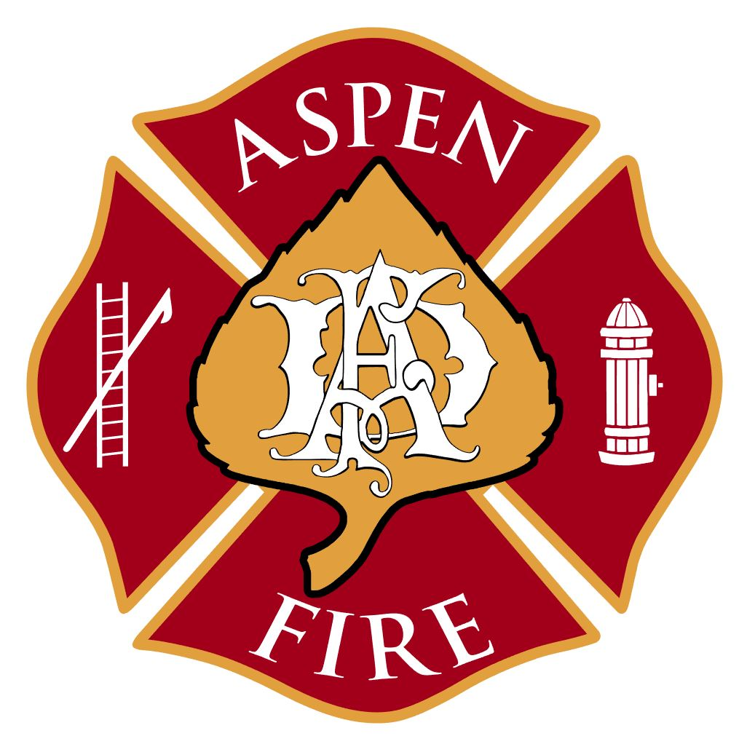

420 E Hopkins Avenue ▪ Aspen, CO 81611 ▪ 970-925-5532 ▪ www.aspenfire.com

Board of Directors Regular Meeting
May 11, 2021
The Board of Directors of the Aspen Fire Protection District met for their regular meeting. The meeting was open to the public virtually via Zoom.

Meeting called to order by John at 5:07pm

Roll Call:
- Board of Directors Present: John Ward, Denis Murray, Dave (Wabs) Walbert, Stephen Wertheimer
- Board of Directors Absent: Michael Buglione
- Staff/Volunteers Present: Rick Balentine, Jake Andersen, Nikki Lapin, Jan Schubert, Ken Josselyn, Ryan Warren, Michael Holmes
- Public/Others: Sebastian Wanatowicz

Approval of Minutes:

MOTION: Motion by Wabs to approve minutes from: Regular Meeting held on April 13, 2021. Steve second. Discussion: Steve requested that the last amended motion in regards to funding FPPA be adjusted to read “Amended motion by Denis to put excess $295,000 from 2020 General Fund into FPPA. The board also clarified that the $250,000 budgeted in 2021 for FPPA would also be reserved this year for a total of $545,000 contribution during 2021”. The board requested taking out the discussion sentence.

AMENDED
MOTION: Motion by Wabs to approve the minutes as amended. Steve second. All approved.

Public Comment: None

AVFD Inc., Ryan Warren:
- AVFD Inc. had a member meeting in February. Next one will be in May. Ryan has received feedback from firefighters, but minor and no reason to bring to the board at this time. AVFD Inc. is looking forward to hearing about the strategic plan.

North 40 Housing Project Update: Sebastian Wanatowicz
- Excavation is continuing and working through design for a sub-slab drainage system. Sebastian, Rick and Denis are working on request to SGM to eliminate a portion of foundation drainage system that will save money. Now have good data to illustrate that it is not required and have a letter from soils engineer that they are in agreement. This will help mitigate rising costs of framing. Main focus excavating, drilling for micro piles and working on electric. The transformer had to be replaced. Project is on schedule and working through the budget.
- Change Order: There is $40,000 for site drainage piping that goes to dry wells. There will be a change order coming for framing due to rising costs of materials. Currently working on buying out materials for project with all the rising costs.
- Allowance Report: Sebastian will be working on this report for the next meeting.
- The project is currently on schedule within a couple days.
- Renewable Energy Exemption for snowmelt to driveway: Denis would like to make a request for exemption for snowmelt to driveway. Stryker Brown submitted an email regarding exemption due to being a government entity. Denis suggested John request getting on agenda for BOCC.

Financials:
- North 40 Housing Fund budget sits at $15.5 million as of today.
- FPPA 1st Quarter Report: Jan confirmed the $295,000 was sent. The board gave Jan direction to send remaining budgeted amount for 2021.
- Colorado Trust: Steve will look into the different options and plans.

Board Comments & Action Items:
- Salary Study - Denis would like to see the salary study before moving forward with further hiring. Nikki gave an overview as to where the project stands. The information has been received and currently under review by staff. Employer’s Council will be giving us an executive summary in the next week.
- Fire Prevention Positions: Denis suggested contracting some help for Jan Legersky. Jan commented that we currently use Jensen Hughes, however the things needing to be done can’t be contracted out. Historically there have been three people in Fire Prevention. Further discussion was had. Rick commented that at this time the wildfire position is not needed and salary can be reallocated to the Deputy Fire Marshal position. Steve suggested moving ahead with Fire Marshal and Deputy Fire Marshal position with the agreement to get salary data.
- Special Meeting: It was suggested for May 19th at noon to 2pm to discuss strategic plan and salary study. There was further discussion of Fire Marshal and Deputy Fire Marshal positions. Steve suggested talking to other departments to see what data they are measuring, such as KPI.
- John thanked Jake Andersen for connecting him with Aspen Ambulance in regards to getting EMS help for the Aspen Lacrosse Tourney.
Fire Marshal Report:
- Fire Marshal report was included in the board packet. Plan reviews are down a little, but inspections are up. Burn Permit approvals will end in May.

Training Report:
- Training report was included in the board packet. The probies are very busy. There are several training opportunities coming up; Tri-Annual with ARFF, Large Animal Rescue, Live Burn Trailer and Red Card training for wildfire season. Aspen Fire has partnered with Aspen Ambulance for some EMS training and we are helping them with some Red Card training. The board has requested that attendance numbers be added into the report.

Wildfire Report:
- Deputy Chief Andersen gave a brief overview. There have been no wildfires this month. The Collins Creek prescribed burn was 1200 acres. Several members of Aspen Fire were able to go out and observe. It was a huge success. Have been working on first 48 hour attack. Captain Spaulding has been tasked with putting together Incident Action Plan. This will be forward to State and Feds for input.
- Wildfire Mitigation: Working on mitigation and fuel reduction plan with Red Mountain in conjunction with HOA’s, ACES and homeowners, along with applying for a grant. No change in wildfire risk program. Found a couple glitches that have been fixed. There are 43 mitigation assessments set up. They take approximately 4-5 hours per assessment. Doing as many with duty crews and Captain Palmer. Severity Engine will start end of the month and will assist with these. This is wildfire Preparedness month and staff will be pushing out social media outreach. Also have opportunity to have booth at Farmer’s Market over summer.
- Pano AI – Aspen Fire was approached by company with AI equipment for wildfire detection.

CEO/Fire Chief & Good of District
- Woody Creek Station: Rick recommends moving Jake Andersen and his family into the housing until he can find another place. This will help get him in the district. The consensus from the board was to put him into the Woody Creek station.
- AVFD Inc. in conjunction with Aspen Branch handed out Mother’s Day flowers.

Old Business:
- AFD Housing Guidelines and Rental Rates: Guidelines from APCHA were included and it was suggested using this as baseline and add in our own language, along with verbiage for leases. Also, discussion of priority for units and the waterfall effect with goal of it being filled by Aspen Fire. John and Rick will work with Karl Hanlon on language for guidelines, eligibility, rules and lease.
- Strategic Plan Update: Special Meeting scheduled for May 19th. Draft copy has been given to the board for review.

New Business:
- COVID: A question was posed if Aspen Fire had been approached as a vaccination station. At this time, Aspen Fire has not.

MOTION: Motion by Steve to adjourn at 7:04pm. Wabs second. All approved.

*** A full recording of this meeting can be requested by contacting the District Administrator at nikki.lapin@aspenfire.com or by calling 970-925-5532.

