Aspen Fire Protection District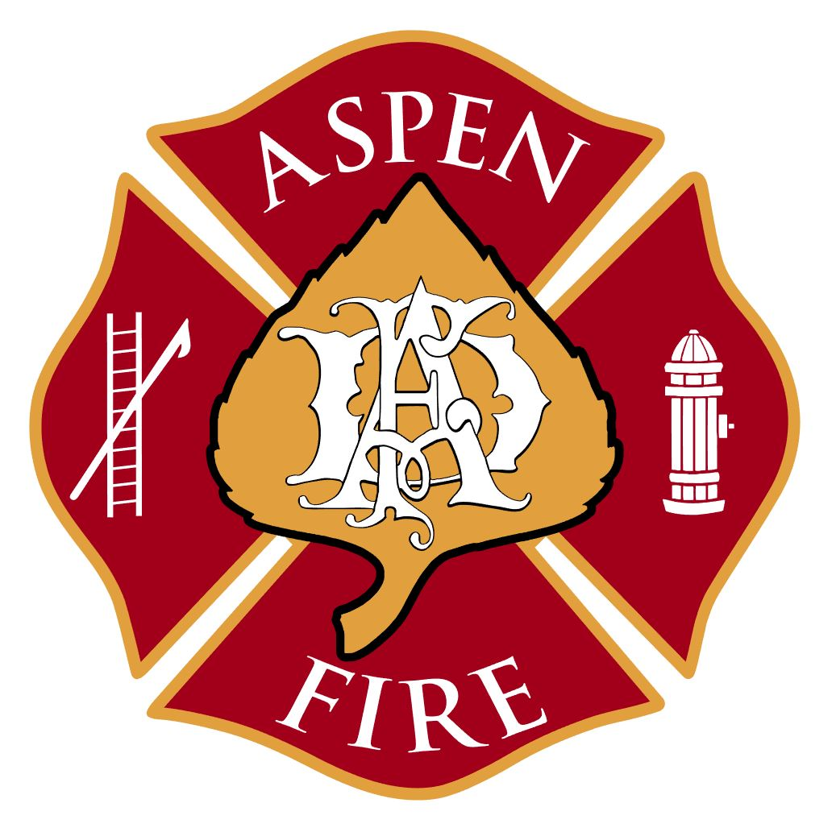

420 E Hopkins Avenue ▪ Aspen, CO 81611 ▪ 970-925-5532 ▪ www.aspenfire.com

Board of Directors Work Session
May 25, 2021
The Board of Directors of the Aspen Fire Protection District met for a work sess. The meeting was open to the public virtually via Zoom.

Meeting called to order by John at 5:30pm

Roll Call:
- Board of Directors Present: John Ward, Denis Murray, Dave (Wabs) Walbert, Michael Buglione , Stephen Wertheimer
- Board of Directors Absent:
- Staff/Volunteers Present: Rick Balentine, Jake Andersen, Arnold Nimmo, Bruce Bradshaw
- Public/Others:

Strategic Plan Review:
- The board met to review and make any final adjustments before finalizing strategic plan. A full recording of this meeting can be requested by contacting the District Administrator at nikki.lapin@aspenfire.com or by calling 970-925-5532.

