Aspen Fire Protection District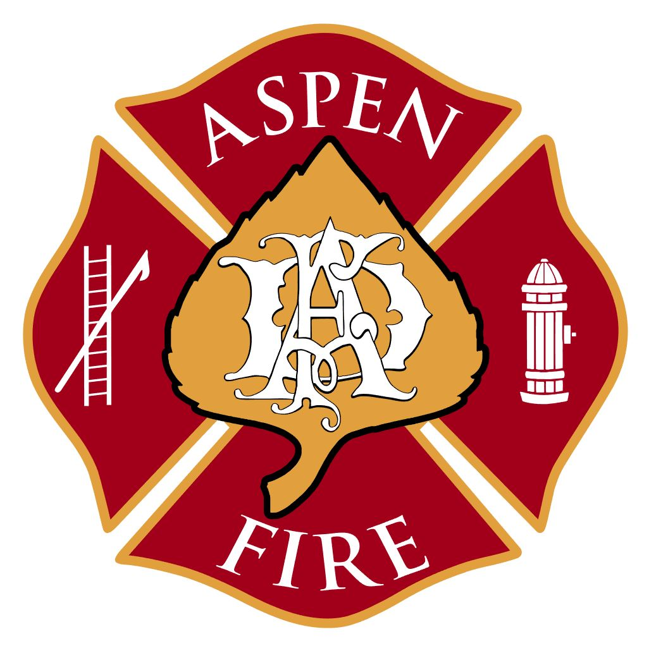

420 E Hopkins Avenue ▪ Aspen, CO 81611 ▪ 970-925-5532 ▪ www.aspenfire.com

Board of Directors Special Meeting
May 20, 2021
The Board of Directors of the Aspen Fire Protection District met for a special meeting. The meeting was open to the public virtually via Zoom.

Meeting called to order by John at 5:03pm

Roll Call:
- Board of Directors Present: John Ward, Denis Murray, Dave (Wabs) Walbert, Michael Buglione , Stephen Wertheimer
- Board of Directors Absent:
- Staff/Volunteers Present: Rick Balentine, Jake Andersen, Nikki Lapin, Ryan Warren, Charlie Curtis, Bruce Bradshaw, Mike Haman, Ken Josselyn, Michael Holmes, Jacob Arywitz, Jake Spaulding, Jan Legersky, Arnold Nimmo, Dan Palmer
- Public/Others: Richard Peterson-Cremer, Carolyn Sackariason, Gabe Muething

Elam Fire: Rick gave a brief overview of the fire. There was approximately a million dollar loss. It was very close to a 6,000 gallon gas tank. It was a great showing from Aspen Fire and surrounding agencies.

Strategic Plan:
- Rick gave a brief introduction to the process and thanked all who participated. The internal staff met several times throughout the process. There was a group of 16 citizens that participated as well that was led by Triton with a good cross selection of people.
- Deputy Chief Jake Andersen presented the strategic plan on behalf of the committee. The board made the following suggestions/comments:
  - Mission Statement: They suggested putting professional upfront to cover everything, not just response. There was further discussion on wordsmithing.
  - Vision: Steve commented that he didn’t see anything about safety of the members and would like to see that build in somewhere.
  - Initiatives, Goals and Objectives: John commented about the order of the initiatives. These were not put in order, just timelines assigned. John felt enhancing EMS delivery and interagency cooperation be placed as priority.
  - Deputy Chief Andersen and Captain Spaulding addressed some question from the board in regards to initiatives taken so far as it pertains to wildfire seasonal staffing, IAP, IMT and opportunities for volunteers.
  - Steve commented about the capability of being successful and prioritizing the list. Staff commented that this is a living document that can be changed and timelines can be moved as needed.
  - The board will hold a Work Session on Tuesday, May 25th at 5:30pm to review the strategic plan further.
  - Mike Haman requested the board be sure to look at what is important to the community and internally and make sure they mesh.
  - Gabe Muething from Aspen Ambulance expressed his feelings that over the last month or so there has been great interaction with Jake, Rick and Aspen Fire board members. He is happy with the way things are going with the progress and changes being made. It is about good communication. He commented that his staff has felt the changes too and would like to see continued success.

Employee Salary Survey:
- Nikki presented a salary and compensation study prepared by Employer’s Council looking at midpoint salaries for surrounding agencies, along with other agencies in Colorado. Minimum salary and maximum salary are based on 80% of the midpoint and 120% of the midpoint per Employer’s Council recommendation. There was much discussion. The board requested some time to absorb the information and discuss at the next regular meeting.
- The board agreed to move forward with the job postings for Fire Marshal, Deputy Fire Marshal and Firefighter/EMT based on the salary ranges from the study.

North 40 Roofing:
- Rick noted that we are at a critical path with the roofing. Umbrella has never given a warranty on section of roof they put in. Roof over the bay was leaking the other day. Rick provided some history on the project and requested direction from the board as to stay with Umbrella or move to another company.

MOTION: Motion by Denis to move on to the second or third bidder or use the company doing roofing for Fire Place project. Wabs second. Discussion: Rick has asked Umbrella if they would pay for a consultant to over see the project if we stayed with them. They would not. Steve suggested to still have a consultant. Rick recommended using the same insulation that is over dispatch to use over the bays. Rick is willing to go back to Umbrella and see if there is anything they can do to give us a better comfort level. After much discussion it was decided to continue with the original motion to move forward with getting updated bids from the second and third bidders. All approved.

North 40 Fire Place Snowmelt:
- There was lengthy discussion about reducing and/or eliminating snowmelt on the planned drive ramp. Denis talked about a G-Ramp renewable energy exemption that may be available and suggesting pursing. The board agreed to go for the ask.

Pano AI Wildfire Detection Program:
- Staff has been working with Red Mountain homeowners on wildfire mitigation. During the process Rick was approached by investor with this company. After multiple meetings, they would like to make Aspen and Aspen Fire their beta site. They will supply 8 cameras on four sites to cover the district. The project is at a cost of $50,000. There is a homeowner that is willing to fund the project. The goal would be to get it up by end of June, beginning of July. It is tied in with infrared satellite and can cross over with other cameras to get latitude and longitude of smoke.

MOTION: Motion by Wabs to adjourn at 7:21pm and also support Rick on this project. Michael second. All approved.

*** A full recording of this meeting can be requested by contacting the District Administrator at nikki.lapin@aspenfire.com or by calling 970-925-5532.

